5.2

The Chinese Diaspora

Causes
- Emigration began in the 10th century with the expansion of maritime trade
  - During colonialism → emigration to Singapore + Mauritius
- Increased with the opening up of China in 1978 (→ migration for business reasons)
- Further fueled globalization
- Chinese government attempts to increase influence with infrastructure projects → simultaneous emigration to the specified area, e.g. Sri Lanka + many countries in Africa (Morocco?)

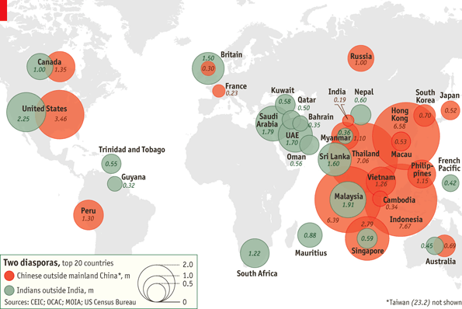
Figures
- 40 million people of Chinese origin are expected to live outside China
- Largest communities: Southeast Asia: 7 million in Thailand, 6.6 million in Hong Kong, 6.4 million in Malaysia and 2.8 million in Singapore; western nations: 3.5 million in the US and 1.35 million in Canada

Effects
- Chinatown exists in many, especially western, cities → contributes to homogenization of cities
- Significant economic power of the Chinese diaspora through
- Remittances
- Financial power invested in host countries
- Chinatowns
  - show the assimilation of Chinese (+ their culture) into the societies of host nations
  - are an important part of Chinese culture + identity
- Chinese investment (abroad) increased in recent years → this has fueled interest for Chinese culture + Mandarin

Figures:
  - In 2010, 750 000 took the Chinese language proficiency test, compared to 117,660 in 2005; an increase of 26.52%
  - England, Wales and Northern Ireland: from 2000-2004 the number of students taking A level exams in Chinese increased by 57%
  - US: 51,582 students study Chinese at college, three times higher than in 1986
  - Many Uzbeks learn Chinese → economic opportunities, esp. due to the planned railway from Xinjiang through Kyrgyzstan to Uzbekistan

The Irish Diaspora

Causes
- Mass emigration from Ireland in the 19th and 20th century
- Poor economic situation (instability)

Facts
- Located in North America (US + Canada), Australia, New Zealand and continental Europe
- Major fluctuations of migrant flows since the 1980’s
1980’s → less going emigrating to Britain
→ More emigrating to other EU nations
→ High rates of return, overall fall in # of emigrants
- Fall of birth rates in the 1980’s + improved economic situation → large scale emigration has ceded (18,000 Irish leave each year, yet many will eventually return [circular migration])

Figures
- Irish population: 5 million
- 80 million people claim Irish ancestry worldwide (>15x Ireland’s population)

irish diaspora in Britain
- 75% of Irish-born people living abroad live in the UK
- 1.7 million living in Britain were born to Irish parents + the third-generation Irish community encompasses 6 million people

irish diaspora in the US
- 30 million claim Irish ancestry (= 10.8% of the US population)
- 156,000 Irish-born live in the US
- US states with the largest Irish population → California, New York + Pennsylvania

Effects
+ Remittances
– Brain-drain → out-migration of talented youth

Diffusion of culture
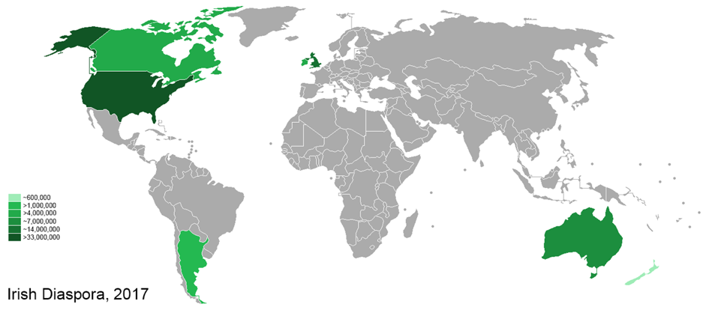
- St. Patrick day parades in US cities, e.g. Chicago, New York + Savannah, Georgia
- Sport (hurling + Gaelic football)
- Traditional Irish music + dance
- Guinness (beer)

