Making Aid Work
Too much of the $300 million in aid to Africa since 1980 has vanished into a sinkhole of fraud, malfeasance and waste. (Sharon LaFraniere, New York Times, July 05)
Reality is broadly the opposite of current popular beliefs. Aid has not been wasted: it has kept African economies afloat through disturbed times. (Paul Collier, "What Can We Expect from More Aid to Africa?" May 06)
Since 1960 nearly $650 billion in aid has been provided to sub-Saharan African (SSA) countries by the OECD Development Assistance Committee (DAC) countries. Has all this aid been gainfully used to promote sustainable growth and development? This is difficult to answer because the links between foreign aid and countries' development are complex. However, the likely answer is, on the whole, "No." Historically, most aid has not been used very well. Much of it was never intended for development to begin with, and a large share went to war-torn and politically unstable countries where development gains have subsequently been lost. However, there is good reason to believe that substantive changes are taking place and that "more and better aid" is now going to finance development programs.
The changing aid picture
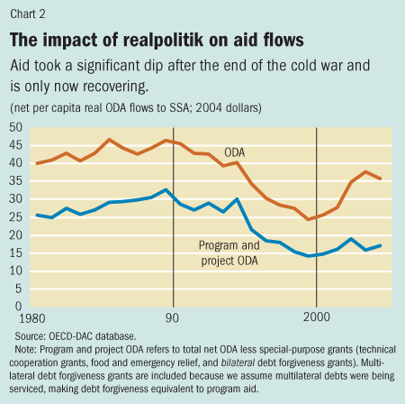
Total aid to Africa from rich countries represents the bulk of reported net financial flows to the continent, accounting for between 40 and 90% in any given year since 1970. While equity and foreign direct investments have grown significantly since the mid-1990s, they are highly concentrated in a small number of countries. For most countries, official development assistance (ODA) is still the largest single source of capital inflows, contributing nearly half of all net capital flows. Following a major decline in the mid-1990s that coincided with the end of the cold war, aid has begun to increase again, although it is still below earlier levels. Per capita aid flows are particularly striking. They declined to $24 per capita in 1999 (nearly half the level seen in the late 1980s) but have since increased to about $37 per capita (see Chart 2).
People typically think of aid as financing for development. But a large amount of aid is not intended for this purpose. OECD countries count a wide range of financing items as ODA, including such special-purpose items as costs linked to program administration, emergency and food assistance, technical cooperation, and debt relief. What remain are "non-special-purpose grants" that constitute what taxpayers typically consider foreign aid: financing for education, infrastructure, and health projects, as well as budget support for general financing needs. Over time, this share of aid going to project and program support has fallen. In per capita terms, the decline in project and program aid during the 1990s was significant, and it has not yet recovered.
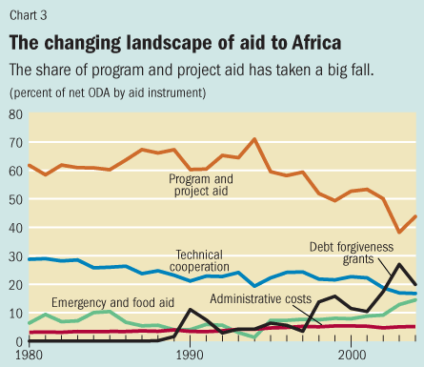
Many factors have contributed to reducing the share of aid that finances development projects. The decline by more than one-third in the share of program and project aid in total ODA—from 63 to 41%—has coincided with increases in the share of administrative costs, debt relief, and emergency aid (see Chart 3). Technical cooperation, much of it spent on foreign advisors, has historically been the second largest component of aid—even though finance for training programs, analytic reports, and expert advice may never actually cross the borders of the donor country. Its share has declined but is still about one-fifth of total ODA, valued at $4.5 billion to Africa in 2004.
Administrative costs on bilateral aid have increased from an average of 5 percent to nearly 8 percent of assistance, in part because of the proliferation of agencies and countries involved in delivering aid—whereas 2 agencies and 10 countries provided aid to Africa in 1960, these numbers had increased to 16 agencies and 31 countries reporting to the DAC by
Debt relief has increased fivefold since the late 1980s and today makes up 20 percent of all ODA. It is recorded as a special-purpose grant in the OECD-DAC system, which reflects the intent to make most debt relief additional to new ODA commitments. Valuing debt relief is quite difficult and warrants further work to improve measurement. But relief on liabilities that are not being (and often cannot be) serviced does not provide a new flow of resources for development, although it does reduce debt overhang. That said, relief for debt that is being serviced and clearly constitutes a claim on future resources may provide a future dollar-for-dollar cash-flow equivalent.
Emergency & food aid has also increased significantly from 7-13% of total ODA since 1980. This type of aid is helpful in a crisis but does not generally contribute to financing long-term development.
Finally, a further practice that reduces the value of official aid is the tying of aid to donor country exports or firms. Tied aid is estimated to be 11–30% less valuable, because of price differentials between what donor country firms charge and what would be available in the market. Throughout the 1980s, more than half of all aid was tied in this way. There are indications that the share of tied aid is declining, but several donors no longer report how much of their aid is tied, making this difficult to confirm. However, based on what data are available, the UN estimates that tied aid reduced the value of bilateral aid sent to Africa by $1.6–2.3 billion (out of $17 billion) in 2003.
Where has the aid gone?
Aid has often been criticized for flowing to dictators and corrupt regimes with little interest in national development. Colonial ties have also historically been a determinant of aid allocation. On the basis of measures developed by the University of Maryland to rate the concentration of power in the executive, known as "Polity IV," about half of total aid during 1960–90 went to countries that had "unlimited executive authority."
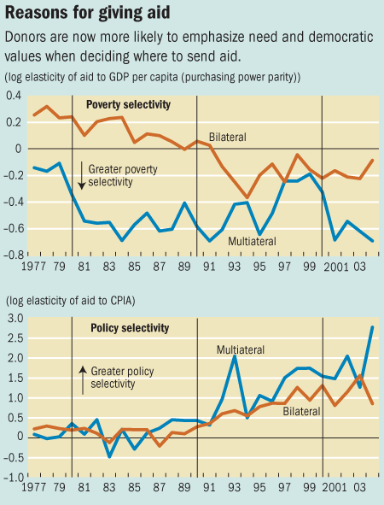
A great deal of aid was also allocated to countries that became politically unstable or endured civil conflict—in fact, 28 countries in Africa have experienced a total of 100 military coups or coup attempts since 1975, and 22 countries have experienced conflict during the past 30 years. From 1980 to 2002, one-fourth of all aid to Africa went to countries experiencing conflict. Nearly one-fifth of total aid went to countries later torn by conflicts that eroded prior development gains.
Some encouraging trends
aid is now going to governments with better civil liberties and political rights. This is due both to greater aid selectivity and to the spread of democratic institutions and multiparty elections in Africa. Aid to countries with unlimited executive authority has fallen from nearly half to 18 percent, and the share of aid to countries with more democratic systems and checks and balances that place restrictions on the executive has nearly tripled.
policy and poverty selectivity have improved significantly. The trend is most marked for multilateral donors, but bilateral donors are also placing much more importance on the quality of governance and overall policies in their aid decisions.
there is a clear recognition of the need to improve aid quality by reducing the number of agencies involved in disbursing aid, harmonizing aid procedures to reduce compliance costs for the recipients, eliminating tied aid, and aligning aid priorities with the countries' own policy priorities.
many countries have improved public resource management by strengthening fiduciary oversight. The public financial management indicators that are being tracked for countries receiving debt relief under the enhanced Heavily Indebted Poor Countries Initiative show that many countries have improved their public expenditure management since 1999, and more indicators are being developed to track performance in other governance areas.
reversal in the high level of capital flight from Africa, which has removed enormous amounts of much-needed financing for development. As political instability subsides and more countries turn to multiparty elections, and as growth picks up and income levels improve, domestic residents repatriate more assets.
In summary, aid in the past was often guided by geopolitical considerations linked to the interests of donor countries rather than by development objectives. Not surprisingly, much of it was used to finance governments that did not have development as their first priority. Furthermore, much aid was not in a form that could be used to finance development (emergency relief and technical assistance are two examples). But changes since the mid-1990s hold clear promise for improving aid quality and effectiveness. The harmonization and alignment of aid under the 2005 Paris Declaration on Aid Effectiveness, as well as the trend toward improved aid allocation selectivity on the basis of need and policy quality, provide evidence of this. This "new aid architecture" can be simply described as aligning aid with country-owned poverty reduction strategies to finance priority social and infrastructural investments, conditional on delivering measurable results. New non-DAC donors and emerging donors, such as China and India, should also learn from DAC donor experience and improve aid alignment in order to enhance the impact of their aid.

