Fact File (Hazards)
Case Study Earthquake: New Zealand (2010)

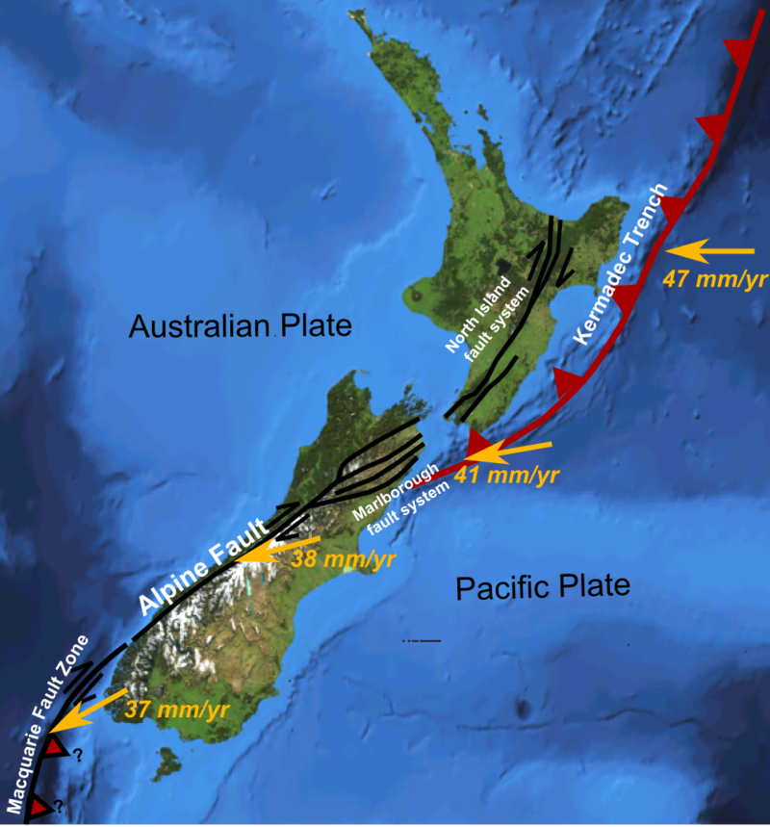

Location:
New Zealand is located in the Pacific Ocean in the continent of Oceania. It is South East of Australia and consists of a North and South Island. New Zealand`s capital is Wellington. It covers 267,710 square kilometers making it the 76th largest nation in terms of land area. New Zealand has a population of 4,327,955 people.
Causes:
The 6.3 magnitude earthquake struck New Zealand at 12:51 on 22 February. The epicenter was 6 miles Southeast of Christchurch and the focus was very shallow at 3.1 miles. The Earthquake occurred on a conservative plate margin where the Pacific Plate slid past the Australian Plate in the opposite direction. A larger earthquake occurred in 2010 so the second earthquake was technically an aftershock, but the impacts were more severe.

Effects:
Primary (caused directly by the earthquake) | Secondary (result from primary effects)
181 people were killed and around 2,000 were injured | Business were put out of action for long periods causing losses of income and jobs
50 per cent of Central buildings severely damaged including the city’s cathedral | Damage to roads through liquefaction (where the ground gets saturated and loses strength) made it difficult for people and emergency services to move around
Hundreds of kilometers of water and sewage pipes were damaged | Schools had to share classrooms due to the damages of other school buildings
Part (size of 20 football fields) of the country’s longest glacier was broken off creating a large iceberg | Christchurch could no longer host Rugby World Cup matches so lost the benefits, e.g. tourism and income, they would bring
80 per cent of the city was without electricity

Development:
- the GDP per capita was $27,700 per person each year.
- the life expectancy was 81 years.
- there were 2.4 doctors per 1,000 people.
- adult literacy was 99% over 15 years old can read/write
- 100% of people have access to clean water
Responses:
Short term | Long term
cared for the most vulnerable people and ensured people were safe from dangerous buildings | paid $898 million in building claims
chemical toilets were provided for 30,000 residents | provided temporary housing and ensured all damaged housing was kept water tight
Areas were zoned to classify damage/cost of repairs | water and sewerage system were restored for all residents by August
international aid was provided in the form of money (around $6-7 million) and aid workers | roads and houses were cleared of silt from liquefaction by August and 80% of roads 50% of footpaths were repaired

